UNISEX SPORTS, Accessories & Uniform

for

Nursery, pRE-PREP & Prep
If you would like to buy anything from this list below please contact:-
Claire on 07957493581 or email cblyth79@googlemail.com

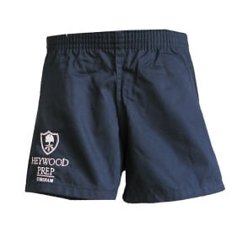
"Heywood Shorts, 20"" to 24"" Waist"
£7.00
Item No | Size | Green 50% £3.50 | Blue 35% £2.45
292 | 20” | Stethridge
293 | 20” | Stanley
294 | 20” | FOH
295 | 20” | Stanley
296 | 20” | Gower
297 | 20” | Weeden
298 | 20” | FOH
299 | 20” | FOH
300 | 20” | FOH
301 | 22” | Zino
303 | 22” | FOH
304 | 22” | Harrison
306 | 22” | Reeves
307 | 22” | Reeves
308 | 22” | Barrett
309 | 20” | Herbert
310 | 20” | FOH
311 | 20” | Cockett
312 | 20” | FOH
313 | 20” | Reeves
314 | 20” | Herbert
315 | 20” | Alford
316 | 24” | Barrett
317 | 20” |  | FOH
318 | 20” |  | Dawson
319 | 24” | Higles
614 | 22” | Wallis
623 | 22” | Harvey
622 | 22” | Harvey
641 | 20” | FOH
642 | 24” | FOH
643 | 20” | FOH
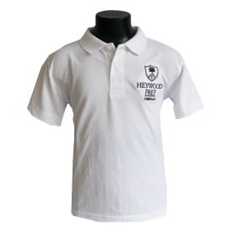
Heywood Polo
£9.50
Item No | Size | Green 50% £4.75 | Blue 35% £3.33
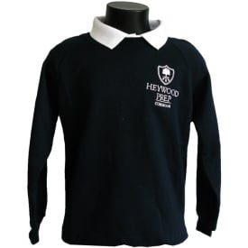
"Heywood Hooded Top, Age 1-8
£16.50
Item No | Size | Green 50% £5.50 | Blue 35% £3.85
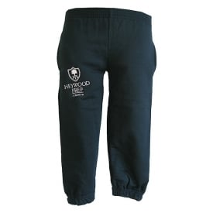
"Heywood Joggers, 18"" to 24"" Waist"
£13.00
Item No | Size | Green 50% £6.50 | Blue 35% £4.55
275 | 19” / 3-4 years | Drake
276 | 22” / 9-10 years | FOH
278 | 20” / 5-6 years |  | Harrison
279 | 22” / 9-10 years | Stanley
280 | 22” / 9-10 years | FOH
281 | 20” / 5-6 years | Cockett
282 | 22” / 9-10 years | Zino
283 | 20” / 5-6 years | Reeves
284 | 22” / 9-10 years | Harrison
286 | 20” / 5-6 years | Addison
287 | 20” / 5-6 years | Alford
288 | 20” / 5-6 years | FOH
289 | 22” / 9-10 years | Jenkins
290 | 22” / 9-10 years | Green
613 | 22” / 9-10 years | Ghuman
615 | 18” | FOH
618 | 19” / 3-4 years | Harvey
627 | 19” / 3-4 years | FOH
628 | 19” / 3-4 years | FOH
625 | 20” / 5-6 years | FOH
626 | 20” / 5-6 years | FOH
627 | 20” / 5-6 years | FOH
637 | 19” / 3-4 years | N. Wallis

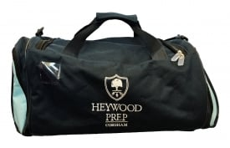
Heywood New Sports Holdall
£22.50
Item No | Size | Green 50% £11.25 | Blue 35% £7.88
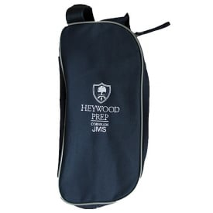
Heywood Boot Bag
£8.00
Item No | Size | Green 50% £4.00 | Blue 35% £2.80
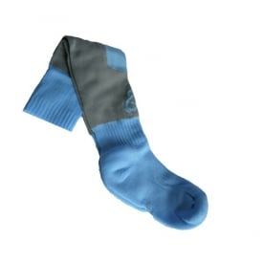
Heywood Games Socks, Size 12 to 6
£7.50
Item No | Size | Green 50% £3.25 | Blue 35% £2.63
153 | M | FOH
655 | S | Hagelthorn
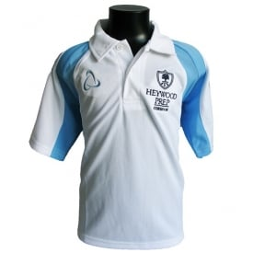
Heywood Polo Shirt, All sizes
£15.00
Item No | Size | Green 50% £7.50 | Blue 35% £5.25
172 | 5-6 | Bicknell
173 | 13-14 |  | Donnelly
361 | 9-10 years | Colwell
628 | 7-8 years | FOH
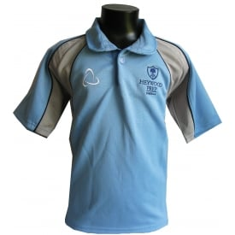
Heywood Games Shirt, All Sizes
£25.00
Item No | Size | Green 50% £12.50 | Blue 35% £8.75
160 | 11-12 |  | Goymer
162 | 13-14 | Kanzurovska
163 | 9-10 | Midwinter
164 | 5-6 | Sentha
165 | 9-10 | Maxine Burton
166 | 5-6 | Mrs Bicknell
253 | 5-6 Years | Mrs Hutter
254 | 9-10 Years | Colwell
629 | 9-10 years | FOH
632 | 9-10 years |  | FOH no writing on the back!
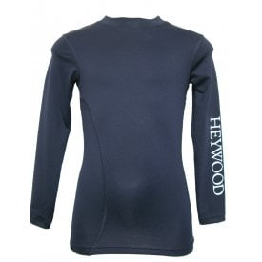
Heywood Base layer Top, All Sizes
£20.00
Item No | Size | Green 50% £10.00 | Blue 35% £7.00
645 | 32” in white | Hagelthorn
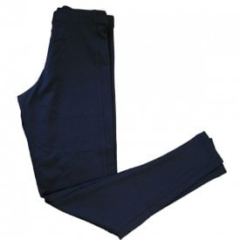
School Baselayer Bottoms 20-26 Inch
£19.00
Item No | Size | Green 50% £9.50 | Blue 35% £6.65
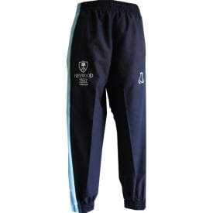
Heywood Tracksuit Bottoms, All Sizes
£22.50
Item No | Size | Green 50% £11.25 | Blue 35% £7.87
167 | 20in | Drake
168 | 20in | Bibby
169 | 20in | Helen Owen
170 | 20in | Bicknell
239 | 18” | Hutter
240 | 24” | Bicknell
242 | 20” | Avant
321 | 22” | Coxall
398 | 20” | Blyth
624 | 18” | Britain
644 | 26” |  | Hagelthorn
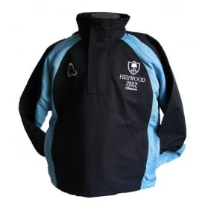
Heywood Smock Top, All Sizes
£30.00
Item No | Size | Green 50% £15.00 | Blue 35% £10.50
243 | 11-12 Years |  | Goymer
244 | 79- Years | Senthe
245 | 11-12 Years | Colwell
246 | 7-8 Years | Avent
247 | 13-14 Years | Goymer
249 | 5-6 Years | Hutter
250 | 7-8 Years | Hewitt
251 | 7-8 Years | Burton
636 | 11-12 years |  | FOH
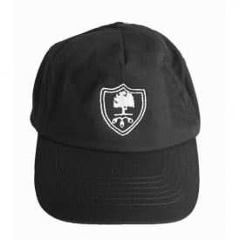
Heywood Baseball Cap
£6.00
Item No | Size | Green 50% £3.00 | Blue 35% £2.10
142 | - | FOH
143 |  |  | Mrs Goymer
144 |  | Kate Bicknell
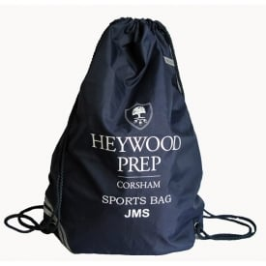
Heywood Drawstring Sports Bag
£7.00
Item No | Size | Green 50% £3.50 | Blue 35% 2.45
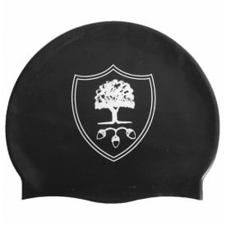
Heywood Swimming Cap
£6.00
Item No | Size | Green 50% £3.00 | Blue 35% £2.10
382 | One size | Goymer
383 | One size | Bicknell
384 | One size | Midwinter
385 | One size | FOH
386 | One size | Goymer
387 | One size (Donnay) | Bicknell
388 | One size | Goymer
389 | One size | Drake

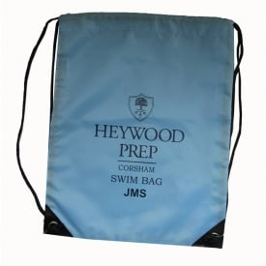
Heywood Drawstring Swim Bag
£7.00
Item No | Initials | Green 50% £3.50 | Blue 35% £2.45
391 | JD | Dent
392 | GEW | Goymer
393 | VG |  | Goymer
394 | JS | FOH
395 | AC | FOH
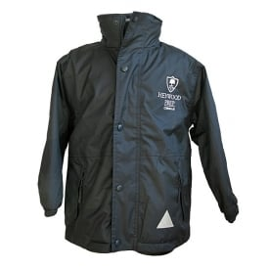
Heywood Winter Fleece Lined Jacket, All Sizes
£26.00
Item No | Size | Green 50% £13.00 | Blue 35% £9.10
255 | XS 3-4 Years | Mulcahy
259 | S 5-6 Years | Goymer
260 | XS 3-4 Years | Addison
261 | XS 3-4 Years | Clowes

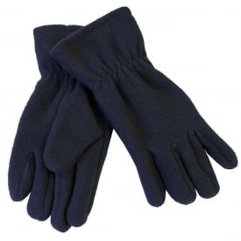
School Fleece Glove
£4.50
Item No | Size | Green 50% £2.25 | Blue 35% £1.58

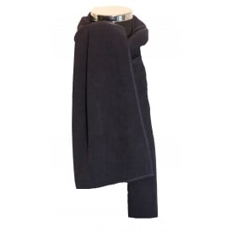
School Fleece Scarf
£5.00
Item No | Size | Green 50% £2.50 | Blue 35% £1.75
139 | - |  | Mrs Dent
141 | - | FOH
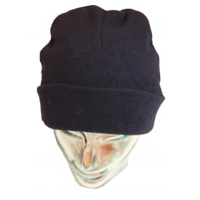
School Fleece Hat
£5.00
Item No | Size | Green 50% £2.50 | Blue 35% £1.75
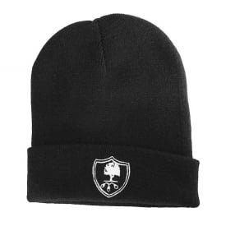
Heywood Beanie
£6.00
Item No | Size | Green 50% £3.00 | Blue 35% £2.10
137 | - | T Cockett
138 | - |  | FOH
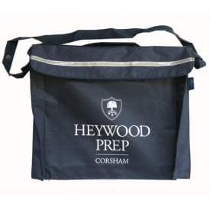
Heywood Bookbag
£10.00
Item No | Size | Green 50% £5.00 | Blue 35% £3.50
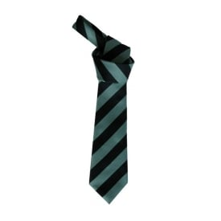
Heywood Tie
£4.50
Item No | Size | Green 50% £2.25 | Blue 35% £1.58
630 | One Size | FOH
631 | One Size | FOH
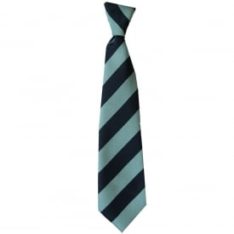
Heywood Elasticated Tie
£4.50
Item No | Size | Green 50% £2.25 | Blue 35% £1.58
272 | One Size | FOH
273 | One Size | FOH
632 | One Size |  | X6 free
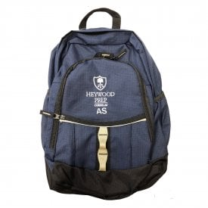
Heywood Rucksack
£22.00
Item No | Size | Green 50% £11.00 | Blue 35% £7.70
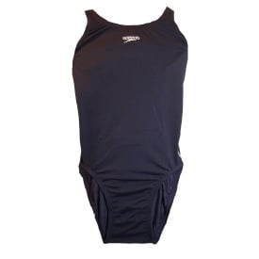
Speedo Swim Suit 22”-32” Chest
£15.00
Item No | Size | Green 50% £7.50 | Blue 35% £5.25
363 | 22” | Zino
364 | ?(Year 4) | Owen
365 | 22” | Owen
366 | 26” 8 years | Stethridge
367 | 24” 6 years | Addison
368 | 26” 8 years | FOH
369 | 24” 6 years | FOH
370 | 28” | FOH
371 | 26” 6 years | Turner
372 | 24” | FOH
390 | 22” | Bicknell
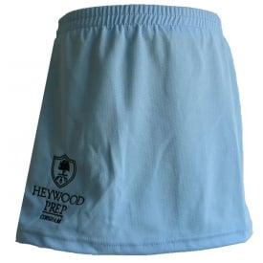
Heywood Skort, All Sizes
£16.00
Item No | Size | Green 50% £8.00 | Blue 35% £5.60
263 | 22” | Colwell
264 | 20” | Bicknell
266 | 22” | Mears
268 | 22” | Burton
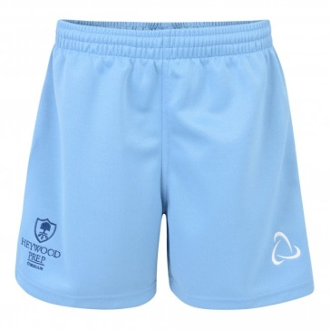
Heywood Boys Rugby Shorts
£12.00
Item No | Size | Green 50% £6.00 | Blue 35% £4.20
638 | 22” | Britain
639 | 20” | Britain
640 | 24” | FOH

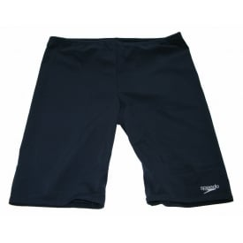
Boys Swimming Speedo Shorts 22-30” Waist £14.00
Item No | Size | Green 50% £7.00 | Blue 35% £4.90
373 | 26” 8 years | Coxall
374 | 26” 8 years | Durrant
375 | 28” | Carey
376 | 30” 10 years | Kanzurovska
378 | 24” 7 years | Drake
379 | ? | Dent
380 | 26” 8 years | FOH
381 | 26” 8 years | Willians

